***Note to Speaker! Thank you once again for the opportunity to feature you! And for being excited to share the event! Please know I welcome your personalization’s to this content. Your community is family and I value your connection so much. All of the LOVE pouring into this year’s Dharma Fest by each you is just so beautiful and a sight to behold! With a greatFULL heart, BIG LOVE!
<3 Mavis
Dharma Fest! Solo Invite and Intro Email:
*(please include graphics as they often get the most clicks!)*
>>Recipient Name<< , I just want to tell you, because sometimes we miss telling it to ourselves, you’re doing a great job, and it’s a beautiful thing! <3 But have your expectations of yourself been so high that you have been procrastinating? Has your fear of being truly authentic held you back in your career, relationship, or creativity lately? You’re not alone!
Here’s the thing, the world needs your light now more than ever! It isn’t about getting it right or perfect, it’s about progress and intention! Stepping into what lighting you up will unleash a massive ripple effect in your life and out into the collective!
That’s why I want to introduce you to my friend and dharma driven sacred activator, Mavis Bodine. She discovered that the biggest challenge wasn’t “knowing” her true calling. It was recognizing the limiting beliefs and programs, piled on top of her heart’s passion, that prevented her from clearly connecting and honoring her inner truth.
She knows what it’s like to try and “figure out” out your dharma, as if it’s some code that needs to be cracked. That’s why she is hosting Dharma Fest 2021, a totally FREE online festival! So that you can have fun and ENJOY exploring your unique magic. Take the pressure off of getting it right and watch your fulfillment amplify!
Honoring your soul’s calling, embodying your dharma, and being aligned with your purpose is more than a result or destination. Dharma embodiment is a JOURNEY. In the process, you find your GOLD!

Join me and get Your Free Ticket to Dharma Fest >>HERE!<< (insert your unique link here)

*(Insert Banner with your unique event invite link attached)*
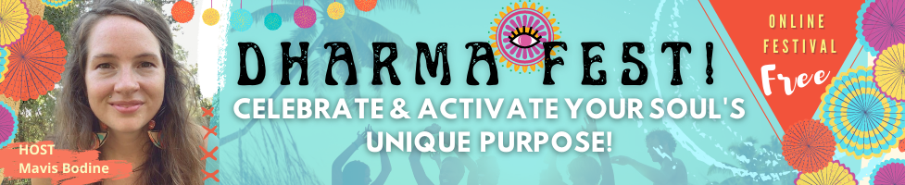
Take a quick look at what you can expect from Dharma Fest!
-Movement/embodiment practices tapping into sacral energy & JOY
-Wisdom on astrology and human design and how it relates to dharma
-Creative intuitive journaling/writing to release, discover, play!
-Drumming to get you connected to body intelligence
-Tarot tools to tap into your intuition
-Awaken the magic within via activation practices
-How to honor your SACRED YES & NO!
-Empowering and exclusive personal insight directly from speakers (totally unique to Dharma Fest!)
And so much more!!!
WE WANT TO SEE YOU SHINE!!
At the end of this 21-day event you’ll feel more connected, intuitive, hopeful, and confident! What if you embraced your truth like never before!? What new possibilities might open up!? What would it be like to have more peace, pleasure, and passion because you trust your heart’s desires and natural gifts?
Dharma Fest is here to encourage, support, and help create clarity so that you can move forward. Not by shoving a bunch of information down your throat, but by taking a journey, having some fun, tapping into your intuition, and connecting with like-minded/hearted leaders like myself!
The time is now, we are living in unprecedented times, and it’s more important than ever for each of us to be empowered and reach that next level of activation in our lives!
Claim your ticket >>HERE<< (insert your unique link here) and celebrate with me at Dharma Fest!
>>SIGNATURE<<
P.S. Imagine a circling of wings and hearts surrounding and encouraging you to take that next step, trust your intuition, believe in yourself, celebrate your authenticity, and know that you are supported! That circle of wings is the heart of Dharma Fest, and it wouldn’t be complete without you!!!
If you’re wondering what other beautiful beings and expert speakers will be there holding this circle, here a just a few! Amanda “Pua” Walsh *Astrology Hub*, Karen Curry Parker *Quantum Alignment/Human Design*, Vix *New Age Hipster*, Brigit Esselmont *Biddy Tarot*, *Singer Speaker* Jana Stanfield, and many more!!!
Join us opening day and grab your ticket >>HERE!!!<< (insert your unique link here)
*(Insert your feature promo graphic with your unique event invite link attached)*
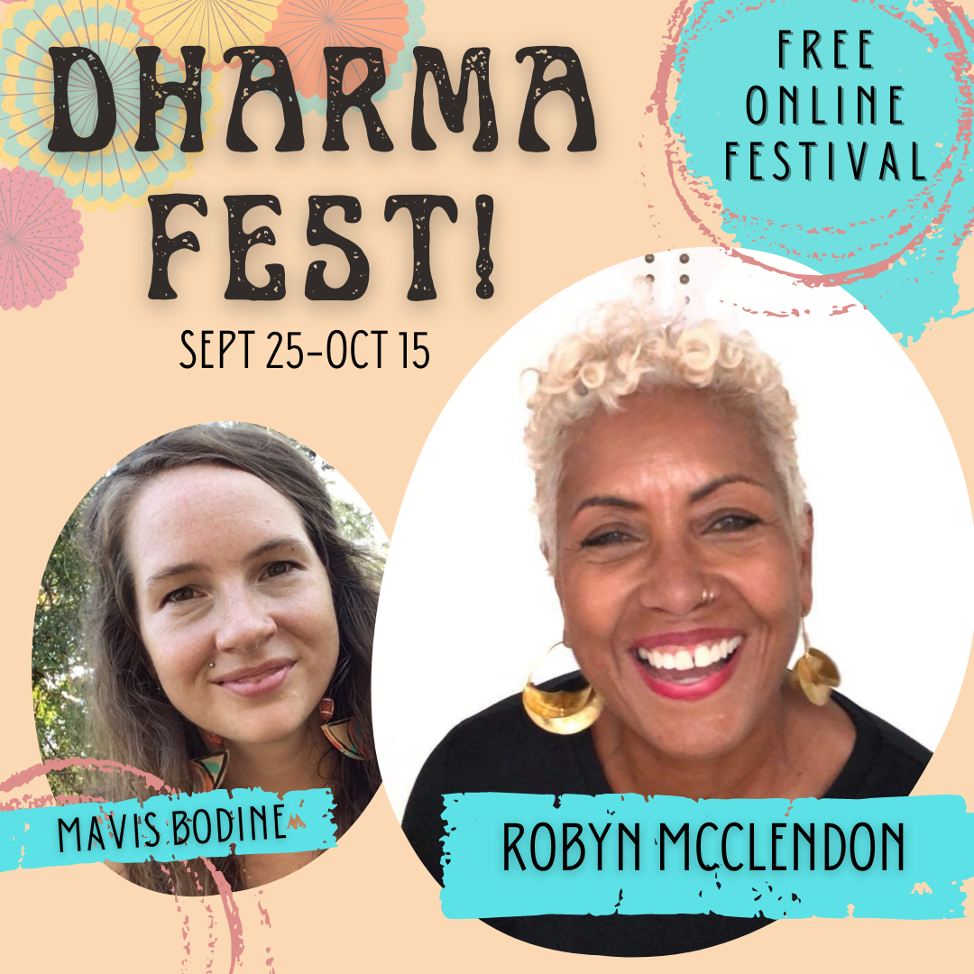

Dharma Fest! Newsletter/Social Post:
Are you ready to get fired up and connected with your authenticity and truth? Do you want to explore your soul’s calling but feel stuck doing the same old, same old? Then you want to join me and my friend Mavis at this year’s Dharma Fest! It’s totally FREE to join and will kick your connection with your own magic into HIGH GEAR! Get ready as our amazing group of speakers takes you on a 21-day journey of expression, discovery, and CELEBRATION! WE WANT TO SEE YOU SHINE! To experience more passion, pleasure, and empowerment than ever before! Grab your >>Ticket<< (insert your unique link here) and I’ll see you there!

Dharma Fest! Newsletter/Social Share:
What if activating your soul’s calling was fun!? What if it meant you would connect with more like minds + hearts!? What if it meant loving and accepting yourself more than ever before!? WELL GUESS WHAT!? That’s EXACTLY what it means! It’s time to stop censoring your truth, sacrificing your play, and embrace your passion! There is a source of energy in you that’s ready to take off. The problem is, if it’s not being used for something that light’s you up within, then you’ll burn out. That’s why I’m inviting you to come to Dharma Fest this year! It’s a FREE online festival hosted by my friend Mavis of Wild Mystic. I’ll be sharing my personal journey and tools that I know can support you too! So many other powerful speakers, musicians, intuitives, and creatives are going to be there offering the gifts! Come ACTIVATE and CLEBRATE the next step of your journey with us! Grab your >>Ticket<< (insert your unique link here) and I’ll see you there!

